Marathon Simulation Project

Introduction
The Marathon Simulation Project is a desktop application designed to simulate a marathon competition. This application will be developed using Visual Studio, and SQL Server as the database. In this application, users can manage the list of participants, simulate the race, and view the final rankings of the marathon after the simulation is complete.

Contents
In this test project there are some files and usable resources:
- MarathonSimulation_TP.pdf (Test project file)
- MarathonSimulation_DB.sql (Database Script File)

Project Description and Tasks
- Project Criteria:
- The project name should be “DESKTOP_I_[XX]”, where XX is your PC number.
- Time management is a crucial factor for the success of this project. So, manage your time wisely and submit all your works on time.
- Application User Interface:
- The application wireframe is already provided. You are allowed to modify the application interfaces as long as it doesn’t interfere the business and application flow.
- The scoring will be focused on the features of the application.
- Validation and Error Messages:
- The application must runs well with a proper validation and shows a useful error messages to the user.
- Analyze the required validation(s) that is/are needed in the application. This is one of the scoring criteria for your analytical skills for the project. Any specific validation will be given in the project description.

Entity Relationship Diagram

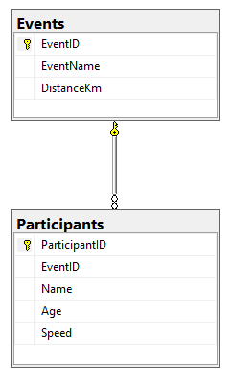

Entity-Relationship Diagram (ERD) is provided to help you understand the database structure of the requested Marathon Simulator Desktop Application. This diagram explains the concept and representation of the data model that is used in the database.

- Main Form

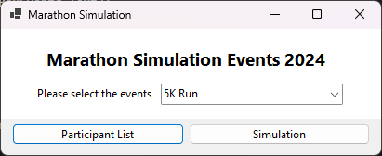

The main screen of the application should include:
- Combobox "Marathon Event": Allows the user to select the marathon event to be simulated getting from the database.
- Navigation Buttons:
  - Participants List: Navigates the user to the participants list form.
  - Simulation: Navigates the user to the race simulation form.

- Participant List Form

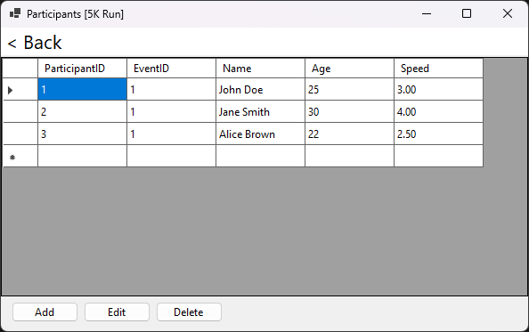

In this screen, the application should display the list of participants in the selected marathon event and form title “Participants [EVENT NAME]”:
- Add Participant: Allows the user to add a new participant by entering their name, age, and running speed in meters per second (m/s).
- Edit Participant: Allows the user to edit the information of an existing participant.
- Delete Participant: Allows the user to delete a participant from the list.
- Back button: To close the form, and back to main form

- Add and Edit Participant Form

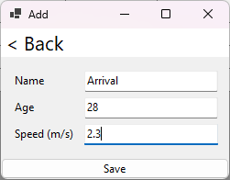 | 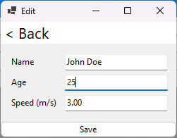

In this screen, user could navigate into other form
- Name,
  - Required.
- Age,
  - Required,
  - Must be a number, cannot be filled with decimal numbers.
- Speed (meter/second),
  - Required,
  - Must be a decimal number with maximum two zeros after the comma.
- Form title
  - “Add” for add participant data
  - “Edit” for edit participant data
- Back button: To close the form, and back to participant list form

- Simulation Form

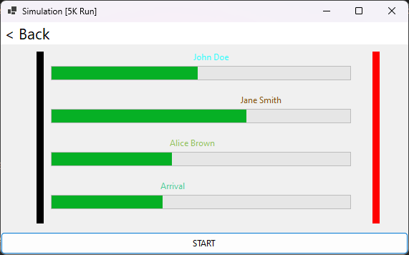

In this screen, the application should display a simple map with a starting, finishing point and form title “Simulation [EVENT NAME]”:
- Participants: List of participants in the selected events, showing dynamically for each participant.
- Participant Label: Appear at the starting point when the "Start" button is pressed, and move according to the participant's speed in meters per second (m/s) until they reach the finish line.
- Start and Finish Lines: Display on the map to indicate the distance and position of the start (Black line) and finish (Red line).
- Progress Bar: Displays the progress of each participant based on the distance they have covered.

Calculating the Distance and Speed
To simulate the marathon, the distance covered by each participant is calculated based on their speed, which is measured in meters per second (m/s). The total distance of the marathon event is determined by the event selected and is measured in kilometers (km).

Formula to Calculate Distance Covered by a Participant:
$$Distance Covered (km)=Speed (m/s)×Time (seconds)$$
Where:
Speed (m/s): The speed of the participant in meters per second.
Time (seconds): The time in seconds during which the participant has been running.

Example Calculation:
If a participant is running at a speed of 5 meters per second (m/s) in a 5 km marathon:

The total distance of the marathon is 5000 meters (since 1 km = 1000 meters).
The time required to complete the race can be calculated as:

$$Time= \frac{Total Distance (meters)}{Speed (m/s)}=\frac{5000}{5}=1000 seconds$$

- Race Ranking Form

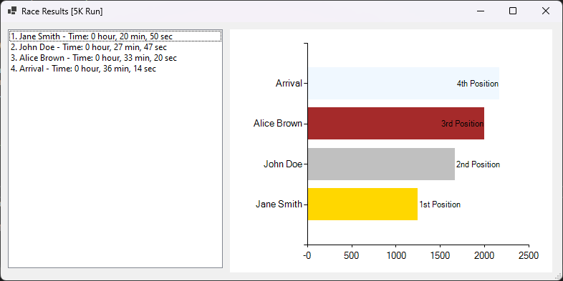

After the simulation is completed, automatically showing the race ranking results:
- Display Ranking List: Display the ranking of each participant based on their finish time.
- Time Details: Show the time taken by each participant to complete the marathon with format: [xx hour, xx min, xx sec].
- Display Chart: Showing the participant times (in seconds) and position place, with detail bar colors: Gold for the 1st position, Silver for the 2nd position, Brown for the 3rd position and Dark Gray for the rest position.

